James Peacemaker

Feb. 7, 2021

CPSC 405

I ended up not working with anyone in my group. They blew threw it really fast in the breakout room and I couldn't keep up. I didn't want to slow them down as I am still learning C. I ended up doing it on my own at my own pace.

Main Args Lab – Answer Document

Process Switches - Take One

1. What is printed when invoked as $ ./mainargs –s

-s flag

Loops: 1

1. What is printed when invoked as $ ./mainargs -sun

-s flag

Loops: 1

1. What is printed when invoked as $ ./mainargs -u -u

-u flag

-u flag

Loops: 2

1. What is printed when invoked as $ ./mainargs -u –ussr

-u flag

-u flag

Loops: 2

1. What is printed when invoked as $ ./mainargs –a

invalid flag

Loops: 1

1. What is printed when invoked as $ ./mainargs -a -u

invalid flag

Loops: 1

1. What is printed when invoked as $ ./mainargs -u –a

-u flag

invalid flag

Loops: 2

1. Run the program to verify your answers to the questions above. Copy/paste your run log here.

jpeacemakr@MyPrecious:/mnt/c/Users/Bettina/Desktop/cpsc405/MainArgsLab$ ./mainargs -s

-s flag

Loops: 1

jpeacemakr@MyPrecious:/mnt/c/Users/Bettina/Desktop/cpsc405/MainArgsLab$ ./mainargs -sun

-s flag

Loops: 1

jpeacemakr@MyPrecious:/mnt/c/Users/Bettina/Desktop/cpsc405/MainArgsLab$ ./mainargs -u -u

-u flag

-u flag

Loops: 2

jpeacemakr@MyPrecious:/mnt/c/Users/Bettina/Desktop/cpsc405/MainArgsLab$ ./mainargs -u -ussr

-u flag

-u flag

Loops: 2

jpeacemakr@MyPrecious:/mnt/c/Users/Bettina/Desktop/cpsc405/MainArgsLab$ ./mainargs -a

invalid flag

Loops: 1

jpeacemakr@MyPrecious:/mnt/c/Users/Bettina/Desktop/cpsc405/MainArgsLab$ ./mainargs -a -u

invalid flag

Loops: 1

jpeacemakr@MyPrecious:/mnt/c/Users/Bettina/Desktop/cpsc405/MainArgsLab$ ./mainargs -u -a

-u flag

invalid flag

Loops: 2

1. Experiment with other combinations of switches.

jpeacemakr@MyPrecious:/mnt/c/Users/Bettina/Desktop/cpsc405/MainArgsLab$ ./mainargs

Loops: 0

jpeacemakr@MyPrecious:/mnt/c/Users/Bettina/Desktop/cpsc405/MainArgsLab$ ./mainargs -1

invalid flag

Loops: 1

jpeacemakr@MyPrecious:/mnt/c/Users/Bettina/Desktop/cpsc405/MainArgsLab$ ./mainargs -

Loops: 1

jpeacemakr@MyPrecious:/mnt/c/Users/Bettina/Desktop/cpsc405/MainArgsLab$ ./mainargs --

invalid flag

Loops: 1

Process Switches - Take Two

1. What is printed when invoked as $ ./maingetopts –h

-h: true

-a: false

-d: false

1. What is printed when invoked as $ ./maingetopts –had

-h: true

-a: true

-d: true

1. What is printed when invoked as $ ./maingetopts –hadf

-h: true

-a: true

-d: true

-f needs a value

1. What is printed when invoked as $ ./maingetopts -hadf gusty

-h: true

-a: true

-d: true

-f: gusty

1. Run the program to verify your answers to the questions above. Copy/paste your run log here.

jpeacemakr@MyPrecious:/mnt/c/Users/Bettina/Desktop/cpsc405/MainArgsLab$ ./maingetopts -h

-h: true

-a: false

-d: false

jpeacemakr@MyPrecious:/mnt/c/Users/Bettina/Desktop/cpsc405/MainArgsLab$ ./maingetopts -had

-h: true

-a: true

-d: true

jpeacemakr@MyPrecious:/mnt/c/Users/Bettina/Desktop/cpsc405/MainArgsLab$ ./maingetopts -hadf

-f needs a value

-h: true

-a: true

-d: true

jpeacemakr@MyPrecious:/mnt/c/Users/Bettina/Desktop/cpsc405/MainArgsLab$ ./maingetopts -hadf gusty

-h: true

-a: true

-d: true

-f: gusty

1. Experiment with other combinations of switches. Show your experiments here

jpeacemakr@MyPrecious:/mnt/c/Users/Bettina/Desktop/cpsc405/MainArgsLab$ ./maingetopts -hadd

-h: true

-a: true

-d: true

jpeacemakr@MyPrecious:/mnt/c/Users/Bettina/Desktop/cpsc405/MainArgsLab$ ./maingetopts -hadg

Unknown option

jpeacemakr@MyPrecious:/mnt/c/Users/Bettina/Desktop/cpsc405/MainArgsLab$ ./maingetopts -a -d

-h: false

-a: true

-d: true

jpeacemakr@MyPrecious:/mnt/c/Users/Bettina/Desktop/cpsc405/MainArgsLab$ ./maingetopts -a -f -d

-h: false

-a: true

-d: false

-f: -d

## Experiments and Questions

1. Run you program without arguments.

$ ./my_kill

Error - command format is $ my_kill pid  
Copy/paste your running here.

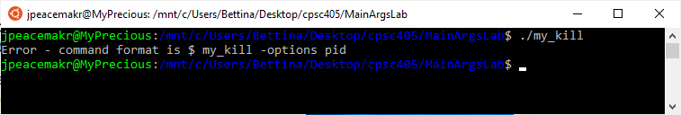

1. Run your program with one integer argument.  
   $ ./my_kill 1234

my_kill pid: 4823

Value of errno: 3

Error printed by perror: No such process

Error killing process: No such process  
Copy/paste your running here.

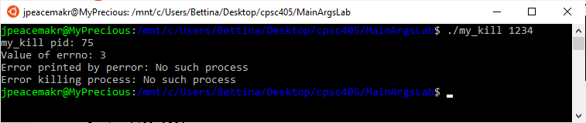

1. Run your program with the -h option and a pid.   
   $ ./my_kill -h 1234  
   Hello World

my_kill pid: 4823

Value of errno: 3

Error printed by perror: No such process

Error killing process: No such process  
Copy/paste your running here.

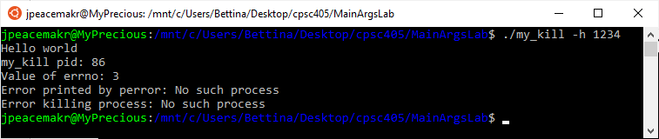

1. Run your program with the -h option, -f option, and a pid.   
   $ ./my_kill -h -f tiny.txt 1234  
   Hello World

Printing file tiny.txt

a

small

file

my_kill pid: 4823

Value of errno: 3

Error printed by perror: No such process

Error killing process: No such process  
Copy/paste your running here.

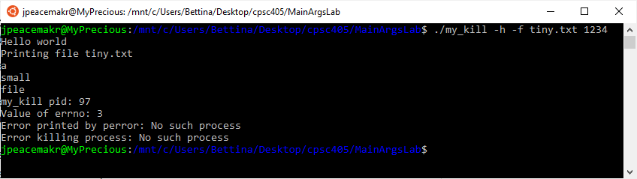

1. Run your program with some combinations of options. Copy/paste your running here.

A few test examples:

* A test using the options together. Like “-hf” instead of “-h –f”
* A test using the file name of a file that does not exist.
* Kill process 0
* Kill process 1
* Using an option that does not exist. “-d”

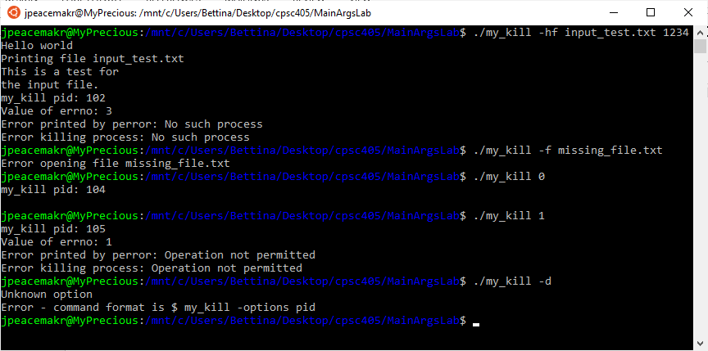

1. Run your program with a string argument. Copy/paste your running here.

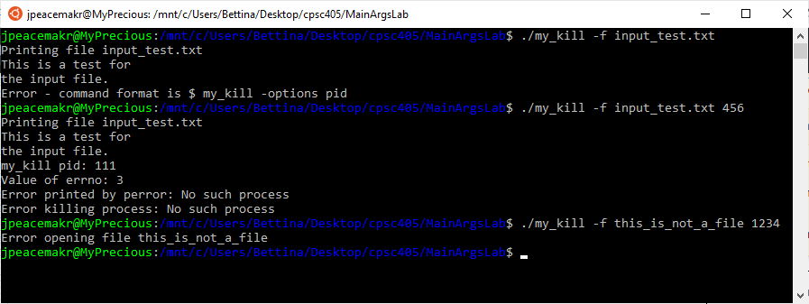

1. You will use my_kill in our Signals Lab. No answer for this question.

Questions

1. Explain argc and argv in your own words.

When a program is run, these are the arguments that can be used by main. argc is the number of arguments in the command.

argv is an array of strings that corresponds to the strings in the command. 0 is the command and the arguments/flags are numbered starting with 1.

1. True/False - The parameters argc and argv must be those names. Justify you answer.

False. argc and argv can be any names just like any function. It is just convention to call them this.

1. What are switches/flags?

Switches/flags are added to a command to change the way a command runs or can be required to provide the program information needed to run.

1. What are two ways to process switches/flags?

Some are just used by themselves (-a) while others require a string following it (-a filename.txt)

1. What is errno? When do you examine errno? What purpose does errno serve?

errno is an error number. It is associated with the error that is returned when a function fails. errno is a global variable that can be used at any time, but is usually checked after running a function that could fail, like opening a file. It can also be used by strerror() to return a string associated with the error.